MONABIPHOT Summer School
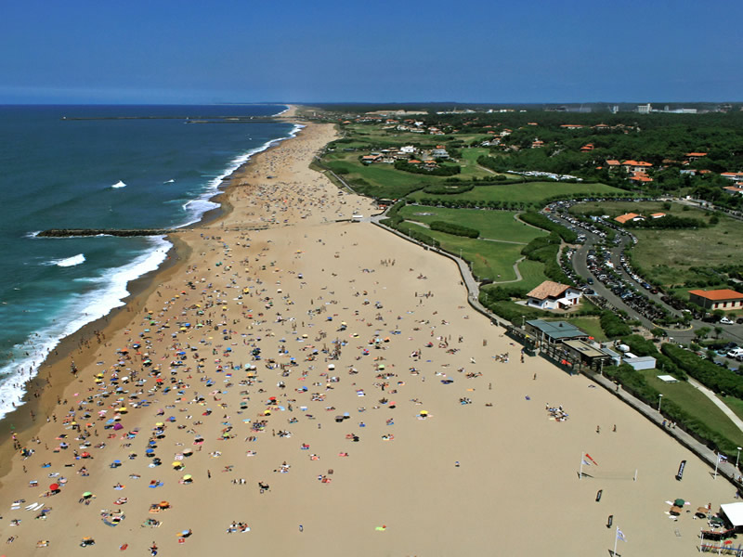
22nd to 28th of June 2014
VENUE: Anglet
AZUREVA
48 Promenade des Sables, 64600 Anglet France
Tél : +33 (0)5 59 58 04 70
comgroupeanglet@azureva-vacances.com

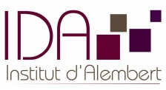
Monabiphot -summer school 2014
The yearly Summer School of the MONABIPHOT Erasmus Mundus Master Course
www.monabiphot.ens-cachan.fr
Organized and chaired by Joseph ZYSS
LPQM and Institut d’Alembert, ENS Cachan, France
Azureva - Anglet

22/06 to 28/06/2014
Joseph Zyss, school director in charge of scientific organisation
Isabelle Ledoux, managing director
Ginette Puyhaubert, school secretary
List of lecturers with affiliations
- Sébastien Bidault Institut Langevin / ESPCI Paris
DNA based engineering in nanoplasmonics

- Maria Angelez Diaz-Garcia ; University of Alicante (Spain)
Organic Lasers

- Abdel El Abed, Laboratoire de Photonique Quantique et Molécualire, ENS Cachan, France
Droplet-based microfluidics for lab-on-chips and biomedical applications
Langmuir Monolayers and supported bilayers: a powerful tool for probing matter at molecular and nanoscopic scales

- Wieslaw Krolikowski, Australian National University, Canberra
Phenomena and applications of Nonlinear Optics

- Lluis Mir , Institut Gustave Roussy, Villejuif, France,
Interaction of Electric Pulses with living organisms

- Jaroslaw Mysliwiec , Polytechnic Institute Wroclaw, Poland
Lasing and random lasing in biopolymeric systems: theory and applications

- Alexander Nosich, Institute of Radiophysics and Electronics, NASU, Kharkiv, Ukraine
Introduction to nanoscale electromagnetism

- Lucia Petti, CNR Pozzuoli, Italy
Nanotechnologies and Metamaterials for Photonics, Optoelectronics and Biosensing

- Blaise Yvert, Inserm Clinatec - Grenoble, France
Electrophysiological recordings of the central nervous system

- Andreas Zumbusch, University of Konstanz, Germany
Spectroscopic approaches to optical microscopy
Schedule
- Sunday 22th of June
Arrivals in the afternoon
19 :30 : Dinner
20:30 – 21:15 : Isabelle Ledoux
Presentation of purpose, schedule and daily life of the School
Short self-introduction by lecturers

- Monday 23th of June
Morning session
08:50 – 09:50 : Wieslaw Krolikowski (1)
Phenomena and applications of Nonlinear Optics: 1. Light localization and spatial solitons

10:00 - 11:00 : Blaise Yvert (1)
Electrophysiological recordings of the central nervous system

Coffee break

11:30 – 12:30 : Luis Mir (1)
Interaction of Electric Pulses with living organisms

Lunch
Afternoon session
17 :00 : Coffee break with pastries

17 :10 – 18 :10 : Abdel El Abed (1)
Droplet-based microfluidics for lab-on-chips and biomedical applications

18 :30 – 19 :30 : Luis Mir (2)
Interaction of Electric Pulses with living organisms

Dinner
After-dinner session
21:00 – 22:00 : Alexander Nosich (1)
Introduction to nanoscale electromagnetism
- Tuesday 24th
Morning session
08:50 – 09:50 : Abdel El Abed (2)
Droplet-based microfluidics for lab-on-chips and biomedical applications

10:00 - 11:00 : Luis Mir (3)
Interaction of Electric Pulses with living organisms

Break
11:30 – 12:30 : Alexander Nosich (2)
Introduction to nanoscale electromagnetism

Lunch
Afternoon session
16 :00 – 17 :00 : Alexander Nosich (2)
Introduction to nanoscale electromagnetism
17 : 00 Coffee break with pastries
17 :15 – 18 :15 : Wieslaw Krolikowski (2)
Phenomena and applications of Nonlinear Optics: 2.Parametric wave interaction in periodic and random nonlinear media

18 :15 – 19 :15 : Blaise Yvert (2)
Development of multielectrode arrays and brain implants

Dinner
Free time

- Wednesday 25th
Morning session
08:50 – 09:50 : Maria-Angeles Diaz Garcia (1)
Organic Lasers : 1. Introduction to organic lasers

10:00 - 11:00 : Wieslaw Krolikowski (3)
Phenomena and applications of Nonlinear Optics: 3. Optical trapping with twisted light
Break
11:30 – 12:30 : Jaroslaw Mysliwiec (1)
Lasing and random lasing in biopolymeric systems: theory and applications

Lunch
Afternoon : Excursion to Pays Basque
Dinner
After-dinner session
21:00 – 22:00 : Andreas Zumbusch (1)
Spectroscopic approaches to optical microscopy
- Thursday 26th
Morning session
08:50 – 09:50 : Maria-Angeles Diaz Garcia (2)
Organic Lasers 2: Organic laser materials

10:00 - 11:00 : Sébastien Bidault (1)
DNA based engineering in nanoplasmonics
Break
11:30 – 12:30 : Abdel El Abed (3)
Langmuir and supported monolayers: a simple approach for probing matter at molecular and nanoscopic scales.

Lunch

Afternoon session
17 :00 – 18 :00 : Maria-Angeles Diaz Garcia (3)
Organic Lasers III: Organic distributed feedback lasers and application to label-free sensors

18 :10 – 19 :10 : Blaise Yvert (3)
Neural prostheses and brain-computer interfaces

19 h 45 : Gala Dinner
21:00 – 23:00 : After-dinner national singing and dancing contest and party
- Friday 27th
Morning session
08:50 – 09:50 : Jaroslaw Mysliwiec (2)
Lasing and random lasing in biopolymeric systems: theory and applications

10:00 - 11:00 : Sébastien Bidault (2)
DNA based engineering in nanoplasmonics

Break
11:30 – 12:30 : Andreas Zumbusch (2)
Spectroscopic approaches to optical microscopy

Lunch
Afternoon session
17 :30 – 18 :30 : Jaroslaw Mysliwiec (3)
Lasing and random lasing in biopolymeric systems: theory and applications

18 :30 – 19 :30 : Andreas Zumbusch (3)
Spectroscopic approaches to optical microscopy

Dinner
Free time

- Saturday 28th
Morning session
Break (store luggage and vacate rooms before 9 :30a.m.)

9:30 – 10 :30 : Sébastien Bidault (3)
DNA based engineering in nanoplasmonics

Break
11 :00 – 11 :30 : Wrap-up, evaluation and Farewell

11 h 45 : Lunch
Departure after Lunch

