**MONABIPHOT Summer School**

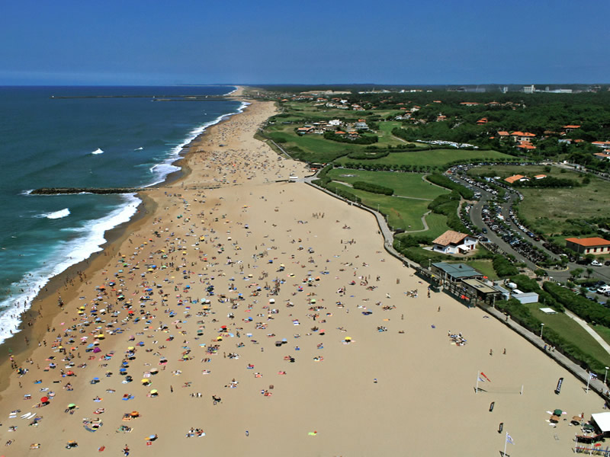

*22nd to 28th of June 2014*



VENUE: Anglet

AZUREVA

48 Promenade des Sables, 64600 Anglet France

Tél : +33 (0)5 59 58 04 70

[comgroupeanglet@azureva-vacances.com](mailto:vtfbiarritz@vtf-vacances.com)

**Monabiphot -summer school 2014**

The yearly Summer School of the MONABIPHOT Erasmus Mundus Master Course

www.**monabiphot**.ens-cachan.fr

Organized and chaired by Joseph ZYSS

LPQM and Institut d’Alembert, ENS Cachan, France

**Azureva - Anglet**

**22/06 to 28/06/2014**

Joseph Zyss, *school director in charge of scientific organisation*

Isabelle Ledoux, *managing director*

Ginette Puyhaubert, *school secretary*

***List of lecturers with affiliations***

* Sébastien Bidault Institut Langevin / ESPCI Paris

*DNA based engineering in nanoplasmonics*

* Maria Angelez Diaz-Garcia ; University of Alicante (Spain)

*Organic Lasers*

* Abdel El Abed, Laboratoire de Photonique Quantique et Molécualire, ENS Cachan, France

*Droplet-based microfluidics for lab-on-chips and biomedical applications*

*Langmuir Monolayers and supported bilayers: a powerful tool  for probing matter at molecular and nanoscopic scales*

* Wieslaw Krolikowski, Australian National University, Canberra

*Phenomena and applications of Nonlinear Optics*

* Lluis Mir , Institut Gustave Roussy, Villejuif, France,

*Interaction of Electric Pulses with living organisms*

* Jaroslaw Mysliwiec , Polytechnic Institute Wroclaw, Poland

*Lasing and random lasing in biopolymeric systems: theory and applications*

* Alexander Nosich, Institute of Radiophysics and Electronics, NASU, Kharkiv, Ukraine

*Introduction to nanoscale electromagnetism*

* Lucia Petti, CNR Pozzuoli, Italy

*Nanotechnologies and Metamaterials for Photonics, Optoelectronics and Biosensing*

* Blaise Yvert, Inserm Clinatec - Grenoble, France

*Electrophysiological recordings of the central nervous system*

* Andreas Zumbusch, University of Konstanz, Germany

*Spectroscopic  approaches to optical microscopy*

**Schedule**

* **Sunday 22th of June**

*Arrivals in the afternoon*

**19 :30 : Dinner**

**20:30 – 21:15** **:** Isabelle Ledoux

*Presentation of purpose, schedule and daily life of the School*

*Short self-introduction by lecturers*

* **Monday 23th of June**

**Morning session**

**08:50 – 09:50 :** Wieslaw Krolikowski (1)

*Phenomena and applications of Nonlinear Optics*: 1. Light localization and spatial  solitons

**10:00 - 11:00 :** Blaise Yvert (1)

*Electrophysiological recordings of the central nervous system*

**Coffee break**

**11:30 – 12:30 :** Luis Mir (1)

*Interaction of Electric Pulses with living organisms*

**Lunch**

**Afternoon session**

**17 :00 :** **Coffee break with pastries**

**17 :10 – 18 :10 :** Abdel El Abed (1)

*Droplet-based microfluidics for lab-on-chips and biomedical applications*

**18 :30 – 19 :30 :** Luis Mir (2)

*Interaction of Electric Pulses with living organisms*

**Dinner**

**After-dinner session**

**21:00 – 22:00 :** Alexander Nosich (1)

*Introduction to nanoscale electromagnetism*

* **Tuesday 24th**

**Morning session**

**08:50 – 09:50 :** Abdel El Abed (2)

*Droplet-based microfluidics for lab-on-chips and biomedical applications*

**10:00 - 11:00 :** Luis Mir (3)

*Interaction of Electric Pulses with living organisms*

**Break**

**11:30 – 12:30**: Alexander Nosich (2)

*Introduction to nanoscale electromagnetism*

**Lunch**

**Afternoon session**

**16 :00 – 17 :00 :** Alexander Nosich (2)

*Introduction to nanoscale electromagnetism*

**17 : 00 Coffee break with pastries**

**17 :15 – 18 :15 :** Wieslaw Krolikowski (2)

*Phenomena and applications of Nonlinear Optics*: 2.Parametric wave interaction in periodic and random nonlinear media

**18 :15 – 19 :15 :** Blaise Yvert (2)

*Development of multielectrode arrays and brain implants*

**Dinner**

**Free time**

* **Wednesday 25th**

**Morning session**

**08:50 – 09:50 :** Maria-Angeles Diaz Garcia (1)

*Organic Lasers :* 1. Introduction to organic lasers

**10:00 - 11:00 :**  Wieslaw Krolikowski (3)

*Phenomena and applications of Nonlinear Optics*: 3. Optical trapping with twisted light

**Break**

**11:30 – 12:30 :** Jaroslaw Mysliwiec (1)

*Lasing and random lasing in biopolymeric systems: theory and applications*

**Lunch**

**Afternoon : Excursion to Pays Basque**

**Dinner**

**After-dinner session**

**21:00 – 22:00 :** Andreas Zumbusch (1)

*Spectroscopic  approaches to optical microscopy*

* **Thursday 26th**

**Morning session**

**08:50 – 09:50 :** Maria-Angeles Diaz Garcia (2)

*Organic Lasers 2*: Organic laser materials

**10:00 - 11:00 :** Sébastien Bidault (1)

*DNA based engineering in nanoplasmonics*

**Break**

**11:30 – 12:30 :**Abdel El Abed (3)

*Langmuir and supported monolayers: a simple approach for probing matter at molecular and nanoscopic scales.*

**Lunch**

**Afternoon session**

**17 :00 – 18 :00 :** Maria-Angeles Diaz Garcia (3)

*Organic Lasers III*: Organic distributed feedback lasers and application to label-free sensors

**18 :10 – 19 :10 :** Blaise Yvert (3)

*Neural prostheses and brain-computer interfaces*

**19 h 45 : Gala Dinner**

**21:00 – 23:00 : After-dinner national singing and dancing contest and party**

* **Friday 27th**

**Morning session**

**08:50 – 09:50 :** Jaroslaw Mysliwiec (2)

*Lasing and random lasing in biopolymeric systems: theory and applications*

**10:00 - 11:00 :** Sébastien Bidault (2)

*DNA based engineering in nanoplasmonics*

**Break**

**11:30 – 12:30 :** Andreas Zumbusch (2)

*Spectroscopic  approaches to optical microscopy*

**Lunch**

**Afternoon session**

**17 :30 – 18 :30 :** Jaroslaw Mysliwiec (3)

*Lasing and random lasing in biopolymeric systems: theory and applications*

**18 :30 – 19 :30 :** Andreas Zumbusch (3)

*Spectroscopic  approaches to optical microscopy*

**Dinner**

**Free time**

* **Saturday 28th**

**Morning session**

*Break (store luggage and vacate rooms before 9 :30a.m.)*

**9:30 – 10 :30 :** Sébastien Bidault (3)

*DNA based engineering in nanoplasmonics*

**Break**

**11 :00 – 11 :30** : *Wrap-up, evaluation and Farewell*

**11 h 45 : Lunch**

**Departure after Lunch**